Nested List
List within list is called nested list
Defining list as element within list is called nested list
Nested list is used to represent data in the form of rows and columns (matrix)

Syntax:[[nested-list-1],[nested-list-2],….]

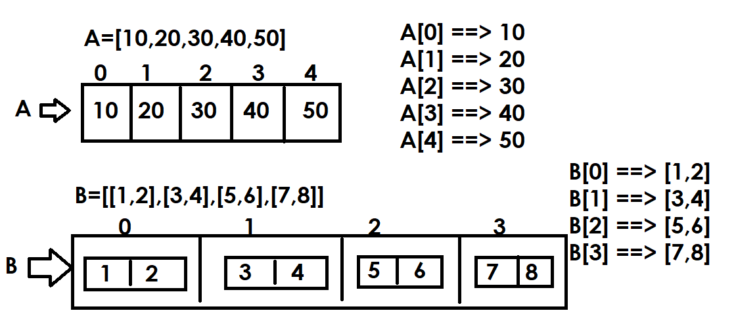

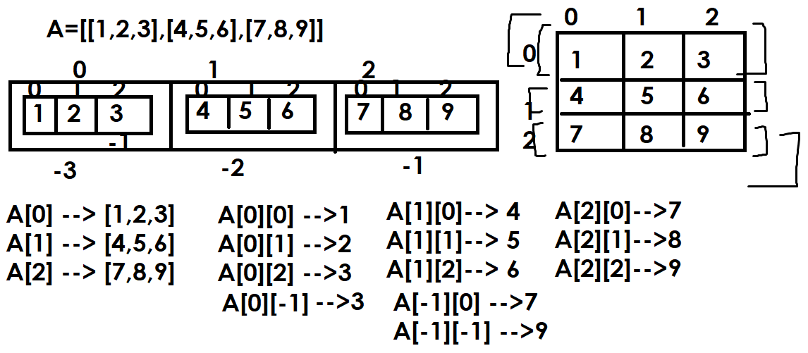

Example:
#Reading content of nested list
A=[[1,2,3],[4,5,6],[7,8,9]]
#Reading with index
for i in range(3): #0 1 2
print(A[i])

for i in range(3): # 0 1 2
for j in range(3): # 0 1 2
print(A[i][j],end=' ')
print()

#Reading elements without using index
for x in A:
print(x)

for x in A:
for y in x:
print(y,end=' ')
print()

Output
[1, 2, 3]
[4, 5, 6]
[7, 8, 9]
1 2 3
4 5 6
7 8 9
[1, 2, 3]
[4, 5, 6]
[7, 8, 9]
1 2 3
4 5 6
7 8 9

Example:
# Printing sum of rows and columns
A=[[1,2,3],[4,5,6],[7,8,9]]
for row in A:
for col in row:
print(col,end=' ')
print()
#Print sum of rows
for row in A:
print(sum(row))

#Print sum of columns
for i in range(3): # 0 1 2
s=0
for j in range(3): # 0 1 2
s=s+A[j][i]
print(s)

Output
1 2 3
4 5 6
7 8 9
6
15
24
12
15
18

Example:
# Write a program to print upper and lower triangle of matrix
A=[[1,2,3],[4,5,6],[7,8,9]]
print("Upper Triangle")
for i in range(3):
for j in range(3):
if i<=j:
print(A[i][j],end=' ')
else:
print(" ",end=' ')
print()

print("Lower Triangle")
for i in range(3):
for j in range(3):
if i>=j:
print(A[i][j],end=' ')
else:
print(" ",end=" ")
print()

Output
Upper Triangle
1 2 3
5 6
9
Lower Triangle
1
4 5
7 8 9

Example:
# Write a program to print transpose of matrix

A=[[1,2,3],[4,5,6],[7,8,9]]

print("Transpose of Matrix")
for i in range(3):
for j in range(3):
print(A[j][i],end=' ')
print()

Output
Transpose of Matrix
1 4 7
2 5 8
3 6 9

Example:
# Write a program to find determent of matrix
# ad-bc
A=[[1,2],[3,4]]

d=A[0][0]*A[1][1]-A[0][1]*A[1][0]

for row in A:
for col in row:
print(col,end=' ')
print()

print(d)

Output
1 2
3 4
-2

Example:
# Write a program to read 3x3 matrix and display

matrix=[]

for i in range(3):
row=[]
for j in range(3):
value=int(input("Enter value :"))
row.append(value)

matrix.append(row)

print(matrix)

Output
Enter value :1
Enter value :2
Enter value :3
Enter value :4
Enter value :5
Enter value :6
Enter value :7
Enter value :8
Enter value :9
[[1, 2, 3], [4, 5, 6], [7, 8, 9]]

Example:
# Write a program to read 3 students 3 subject marks
# calcualte total,avg and result(pass/fail)
stud=[]
for i in range(3):
marks=[]
for j in range(3):
s=int(input(f'Student{i+1} Subject{j+1} Marks'))
marks.append(s)
stud.append(marks)

for marks in stud:
total=sum(marks)
avg=total/3
result="pass"
for s in marks:
if s<40:
result="fail"
break
print(f'{marks}\t{total}\t{avg}\t{result}')

Output
Student1 Subject1 Marks60
Student1 Subject2 Marks70
Student1 Subject3 Marks80
Student2 Subject1 Marks30
Student2 Subject2 Marks70
Student2 Subject3 Marks80
Student3 Subject1 Marks70
Student3 Subject2 Marks80
Student3 Subject3 Marks90
[60, 70, 80] 210 70.0 pass
[30, 70, 80] 180 60.0 fail
[70, 80, 90] 240 80.0 pass

Example:
# Write a program to print sum of two matrices
A=[]
B=[]
C=[]
print("Input Elements of Matrix1")
for i in range(2):
row=[]
for j in range(2):
value=int(input("Enter value "))
row.append(value)
A.append(row)

print("Input Elements of Matrix2")
for i in range(2):
row=[]
for j in range(2):
value=int(input("Enter Value "))
row.append(value)
B.append(row)

for i in range(2):
row=[]
for j in range(2):
row.append(A[i][j]+B[i][j])
C.append(row)

print(A,B,C,sep="\n")
Output
Input Elements of Matrix1
Enter value 1
Enter value 2
Enter value 3
Enter value 4
Input Elements of Matrix2
Enter Value 5
Enter Value 6
Enter Value 7
Enter Value 8
[[1, 2], [3, 4]]
[[5, 6], [7, 8]]
[[6, 8], [10, 12]]

List Comprehension

